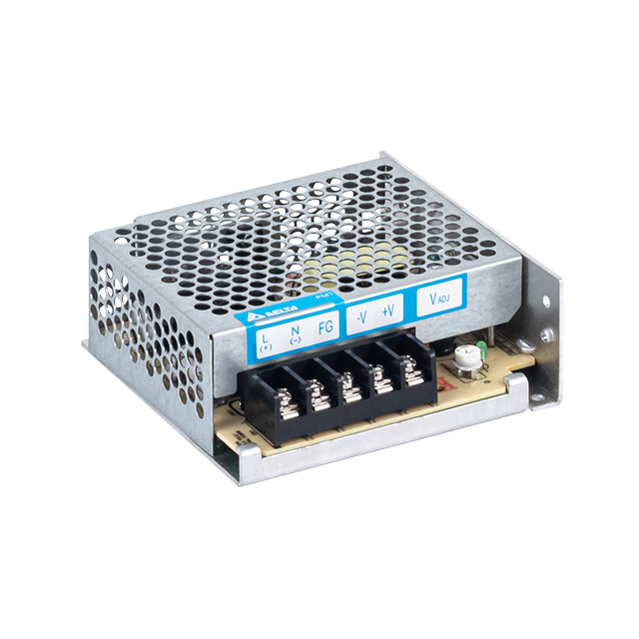**PMT**

# Highlights & Features

* Universal AC input voltage range
* Power will not de-rate from input voltage 90 Vac to 264 Vac
* High MTBF > 700,000 hrs per Telcordia SR-332
* Short Circuit / Overvoltage / Overload / Over Temperature Protections
* Versatile connector options (Terminal Block, Front Face, Harness)

# Safety Standards

  

CB Certified for worldwide use

**Model Number:** PMT-12V35W1A☐☐

**Unit Weight:** 0.22 kg (0.49 lb)

**Dimensions (L x W x H):** 98 x 98 x 38 mm

(3.86 x 3.86 x 1.50 inch)

# General Description

The new PMT series of panel mount power supplies is the latest offering from one of the world’s largest power supply manufacturers and solution providers - Delta. The first range of PMT products will offer a nominal output voltage of 12V with a wide operating temperature range from -10°C to +70°C and can withstand shock and vibration requirements (in accordance to IEC 60068-2-27 and IEC 60068-2-6 respectively). In addition to features like overvoltage and overload protections, Delta’s PMT series of panel mount power supplies is unlike many other brands in the same price level. The PMT series is designed for cost competitive markets without compromising the quality of the components and product specifications. The series of products has an expected life time of 10 years and will have no output power de-rating from 90 Vac to 264 Vac. This versatile series has three different connector options (Terminal Block, Front Face and Harness) and can also be converted into L Frame (PML) or Open Frame (PMB) type of power supplies to satisfy different application needs.

# Model Information

PMT Panel Mount Power Supply

|  |  |  |  |
| --- | --- | --- | --- |
| **Model Number** | **Input Voltage Range** | **Rated Output Voltage** | **Rated Output Current** |
| PMT-12V35W1A☐☐ | 90-264 Vac | 12 Vdc | 2.92 A |

# Model Numbering

|  |  |  |  |  |  |  |  |
| --- | --- | --- | --- | --- | --- | --- | --- |
|  |  |  |  |  |  |  | **CC Code\*\*** |
| **PM** | **🞎 –** | **12V** | **35W** | **1** | **A** | **🞎** | **🞎** |
| Panel Mount | Product Type  T – Enclosed  L – L Frame* B – Open  Frame* | Output Voltage | Output Power | Single Phase | No PFC | Connector Type  A – Terminal Block  G – Front Face* H – Harness* | Blank – Without  connector cover  A – With connector  cover  B – With conformal  coating |

*Options   
**For Enclosed type with Terminal Block   
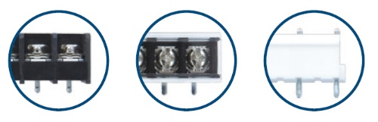

**A G H**

# Specifications

## Input Ratings / Characteristics

|  |  |  |
| --- | --- | --- |
| Nominal Input Voltage | | 100-240 Vac |
| Input Voltage Range | | 90-264 Vac |
| Nominal Input Frequency | | 50-60 Hz |
| Input Frequency Range | | 47-63 Hz |
| Input Current | | < 0.75 A @ 115 Vac, < 0.50 A @ 230 Vac |
| Efficiency at 100% Load | | > 84.0% @ 115 Vac & 23 0Vac |
| Max Power Dissipation | 0% load | 0.29 W typ. @ 230 Vac |
| 100% load | 6.11 W typ. @ 230 Vac |
| Max Inrush Current (Cold Start) | | < 30 A @ 115 Vac, < 60 A @ 230 Vac |
| Leakage Current | | < 1 mA @ 240 Vac |

## Output Ratings / Characteristics*

|  |  |
| --- | --- |
| Nominal Output Voltage | 12 Vdc |
| Factory Set Point Tolerance | 12 Vdc ± 2% |
| Output Voltage Adjustment Range | 11-14 Vdc |
| Output Current | 2.92 A (35 W max.) |
| Output Power | 35 W |
| Line Regulation | < 0.5% typ. (@ 90-264 Vac input, 100% load) |
| Load Regulation | < 1% typ. (@ 90-264 Vac input, 0-100% load) |
| PARD** (20MHz) | < 100 mVpp @ 0°C to 50°C  < 150 mVpp @ -10°C to 0°C |
| Rise Time | < 30 ms @ nominal input (100% load) |
| Start-up Time | < 2500 ms @ nominal input (100% load) |
| Hold-up Time | > 16.7 ms @ 115 Vac (100% load) |
| Dynamic Response (Overshoot & Undershoot O/P Voltage) | ± 5% @ 0-100% load  (Slew Rate: 0.1 A/μS, 50% duty cycle @ 5Hz) |
| Start-up with Capacitive Loads | 8,000 µF Max |

*For power de-rating from 50°C to 70°C, see power de-rating on page 3.

**PARD is measured with an AC coupling mode, 5cm wires, and in parallel with 0.1µF ceramic capacitor & 47µF electrolytic capacitor.

## Mechanical

|  |  |  |
| --- | --- | --- |
| Case Chassis / Cover |  | Aluminium / SGCC |
| Dimensions (L x W x H) |  | 98 x 98 x 38 mm (3.86 x 3.86 x 1.50 inch) |
| Unit Weight |  | 0.22 kg (0.49 lb) |
| Indicator |  | Green LED (DC OK) |
| Cooling System |  | Convection |
| Terminal | PM☐-12V35W1AA☐ | M3.5 x 5 Pins (Rated 300 V / 15 A) |
|  | PM☐-12V35W1AG | M3.5 x 5 Pins (Rated 300 V / 20 A) |
|  | PM☐-12V35W1AH | I/P (JST): B3P5-VH(LF)(SN) O/P (JST): B2P3-VH(LF)(SN) |
| Wire | PM☐-12V35W1AA☐ | AWG 22-12 |
|  | PM☐-12V35W1AG | AWG 22-12 |
|  | PM☐-12V35W1AH | AWG 22-18 (For the recommended Mating Connector and Terminal, please refer to the Table on Page 12) |
| Noise (1 Meter from power supply) |  | Sound Pressure Level (SPL) < 25 dBA |

## Environment

|  |  |  |
| --- | --- | --- |
| Surrounding Air Temperature | Operating | -10°C to +70°C |
|  | Storage | -25°C to +85°C |
| Power De-rating |  | > 50°C de-rate power by 2.5% / °C |
| Operating Humidity |  | 5 to 95% RH (Non-Condensing) |
| Operating Altitude |  | 0 to 5,000 Meters (16,400 ft.) |
| Shock Test | Non-Operating | IEC 60068-2-27, Half Sine Wave: 50G for a duration of 11ms, 3 shocks for each 3 directions |
| Vibration | Non-Operating | IEC 60068-2-6, Random: 5Hz to 500Hz (2.09 Grms);  20 min per axis for all X, Y, Z direction |
| Over Voltage Category |  | II |
| Pollution Degree |  | 2 |

## Protections

|  |  |
| --- | --- |
| Overvoltage | 16 V, +10% / -5%, SELV Output, Hiccup Mode,  Non-Latching (Auto-Recovery) |
| Overload / Overcurrent | > 120% of rated load current, Hiccup Mode, Non-Latching (Auto-Recovery) |
| Over Temperature | Non-Latching (Auto-Recovery) |
| Short Circuit | Hiccup Mode, Non-Latching  (Auto-Recovery when the fault is removed) |
| Internal Fuse at L pin | T3.15 AH |
| Degree of Protection | IPX0 |
| Protection Against Shock | Class I with PE* connection |

*PE: Primary Earth

## Reliability Data

|  |  |  |
| --- | --- | --- |
| MTBF |  | > 700,000 hrs as per Telcordia SR-332 I/P: 100Vac, O/P: 100% Load, Ta: 35°C) |
| Expected Cap Life Time |  | 10 years (115 Vac & 230 Vac, 50% load @ 40°C) |

## Safety Standards / Directives

|  |  |  |
| --- | --- | --- |
| Safety Entry Low Voltage |  | SELV |
| Electrical Safety | TUV Bauart  UL/cUL recognized  CB scheme  BIS  CCC | EN 60950-1, EN 62368-1  UL 60950-1 and CSA C22.2 No. 60950-1 (File No. E131881)  UL 62368-1 and CSA C22.2 No. 62368-1 (File No. E131881) IEC 60950-1, IEC 62368-1  IS 13252 (Part 1) (for PMT-12V35W1AA)  GB 4943.1 (for PMT-12V35W1AA) |
| CE |  | In conformance with EMC Directive 2014/30/EU and Low Voltage Directive 2014/35/EU |
| UKCA |  | In conformance with Electromagnetic Compatibility Regulations 2016 and Electrical Equipment (Safety) Regulations 2016 |
| Galvanic Isolation | Input to Output | 3.0 KVac |
|  | Input to Ground | 1.5 KVac |
|  | Output to Ground | 0.5 KVac |

## EMC

|  |  |  |
| --- | --- | --- |
| Emissions (CE & RE) |  | CISPR 32, EN/BS EN 55032, FCC Title 47: Class B |
| Immunity |  | EN/BS EN 55024 |
| Electrostatic Discharge | IEC 61000-4-2 | Level 4 Criteria A1)  Air Discharge: 15 kV Contact Discharge: 8 kV |
| Radiated Field | IEC 61000-4-3 | Level 3 Criteria A1)  80 MHz-1 GHz, 10 V/M with 1 kHz tone / 80% modulation |
| Electrical Fast Transient / Burst | IEC 61000-4-4 | Level 3 Criteria A1)  2 kV |
| Surge | IEC 61000-4-5 | Level 3 Criteria A1)  Common Mode2): 2 kV Differential Mode3): 1 kV |
| Conducted | IEC 61000-4-6 | Level 3 Criteria A1)  150 kHz-80 MHz, 10 Vrms |
| Power Frequency Magnetic Fields | IEC 61000-4-8 | Criteria A1)  10 A / Meter |
| Voltage Dips and Interruptions | IEC 61000-4-11 | 100% dip; 1 cycle (20 ms); Self Recoverable |
| Low Energy Pulse Test (Ring Wave) | IEC 61000-4-12 | Level 3 Criteria A1)  Common Mode2): 2 kV Differential Mode3): 1 kV |

1) Criteria A: Normal performance within the specification limits

2) Asymmetrical: Common mode (Line to earth)

3) Symmetrical: Differential mode (Line to line)

# Block Diagram

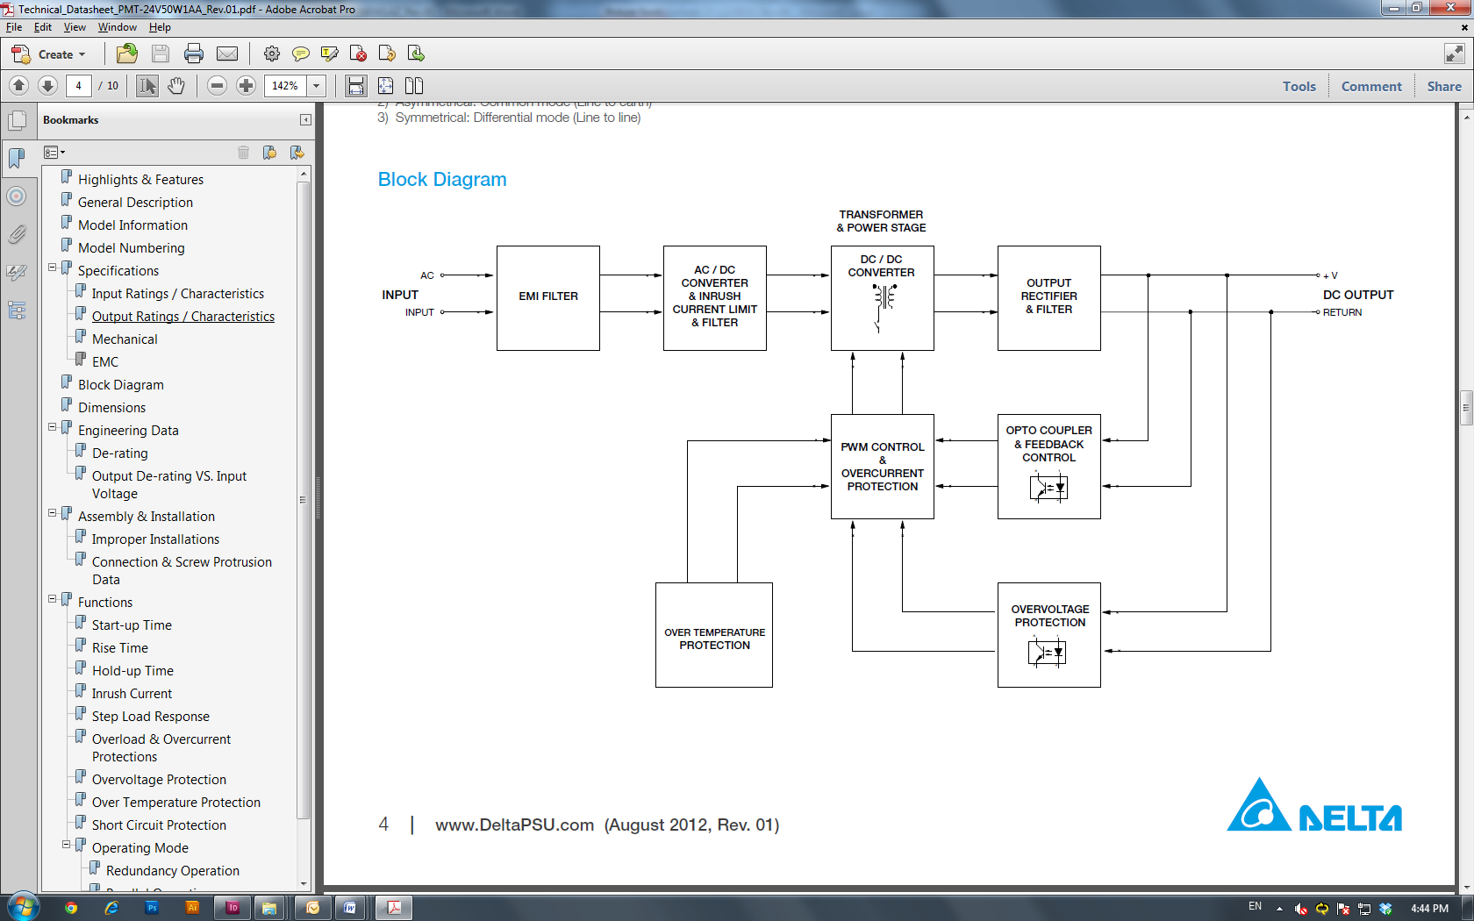

# Device Descriptions

|  |  |  |
| --- | --- | --- |
| **PMT-12V35W1AA☐:** Terminal Block | **PMT-12V35W1AG:** Front Face | **PMT-12V35W1AH:** Harness |
|  |  |  |

1. Input & Output terminal block connector
2. DC voltage adjustment potentiometer
3. DC OK control LED (Green)

# Dimensions

PMT-12V35W1AA☐: Terminal Block

**L x W x H:** 98 x 98 x 38 mm (3.86 x 3.86 x 1.50 inch)

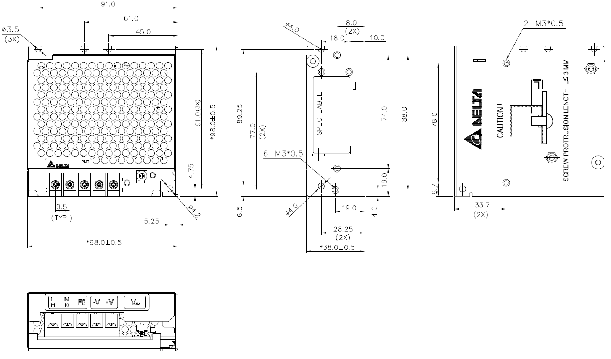

PMT-12V35W1AG: Front Face

**L x W x H:** 98 x 98 x 38 mm (3.86 x 3.86 x 1.50 inch)

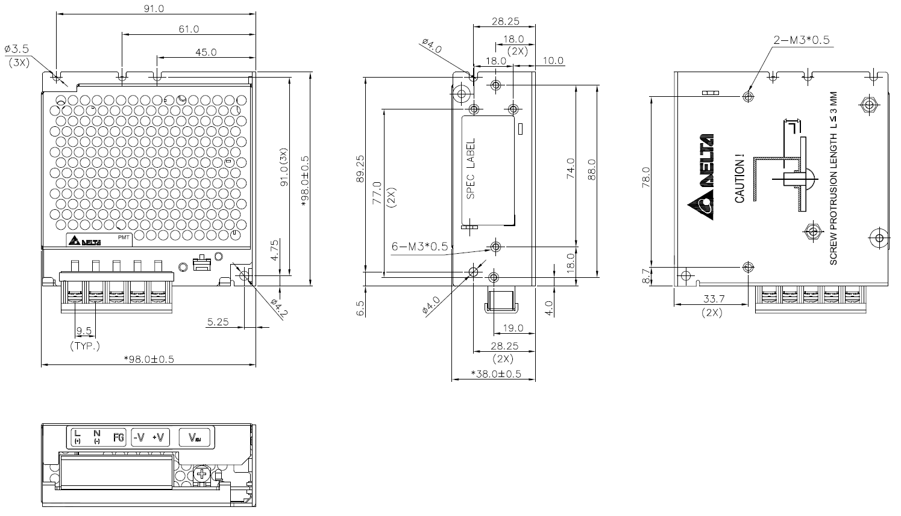

PMT-12V35W1AH: Harness

**L x W x H:** 98 x 98 x 38 mm (3.86 x 3.86 x 1.50 inch)

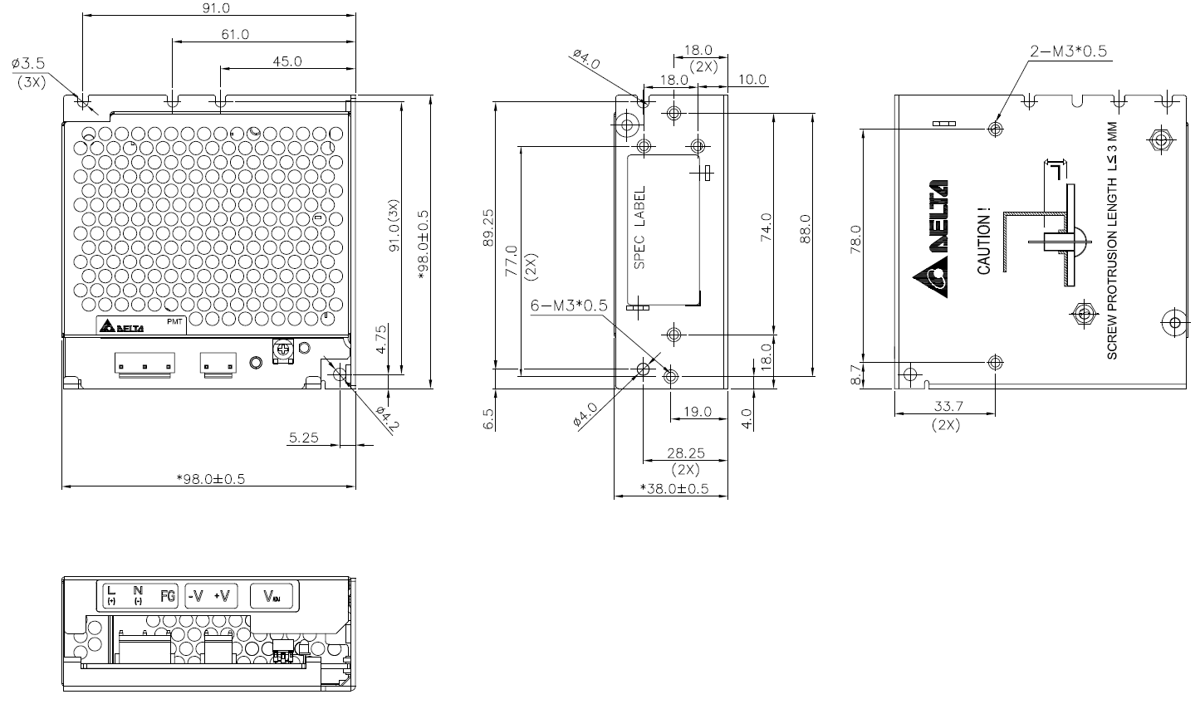

PML-12V35W1AA: Terminal Block

**L x W x H:** 97.5 x 98 x 37.5 mm (3.84 x 3.86 x 1.48 inch)

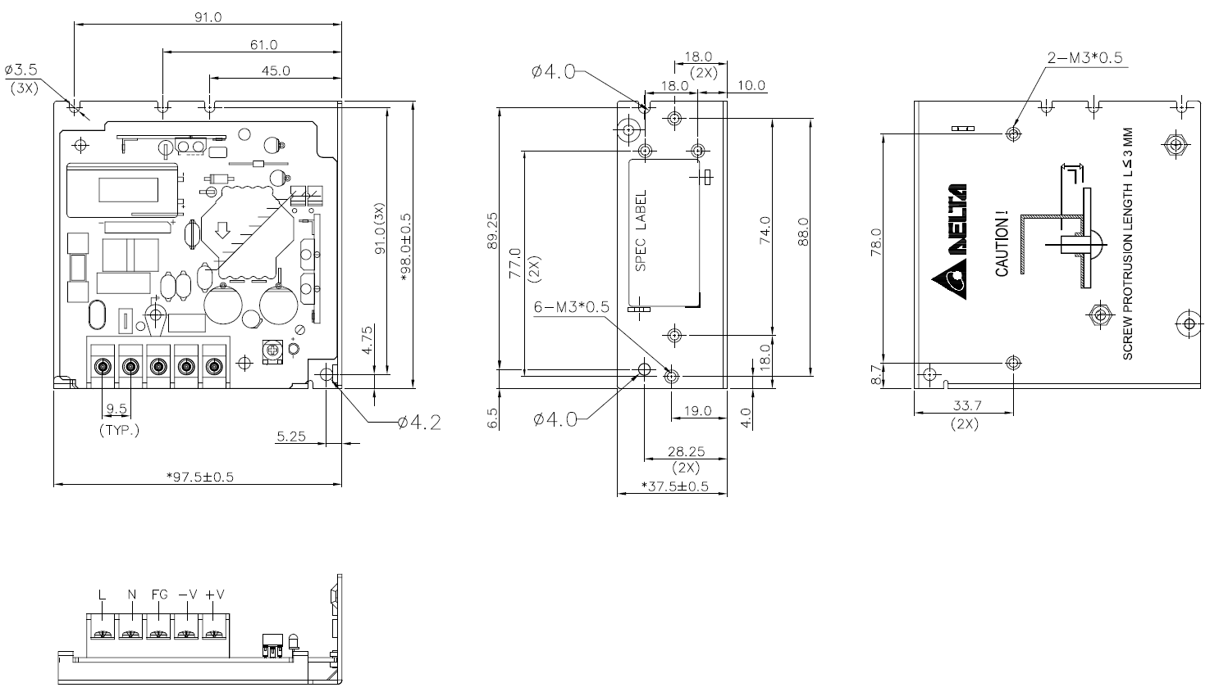

PML-12V35W1AG: Front Face

**L x W x H:** 97.5 x 98 x 37.5 mm (3.8.4 x 3.86 x 1.48 inch)

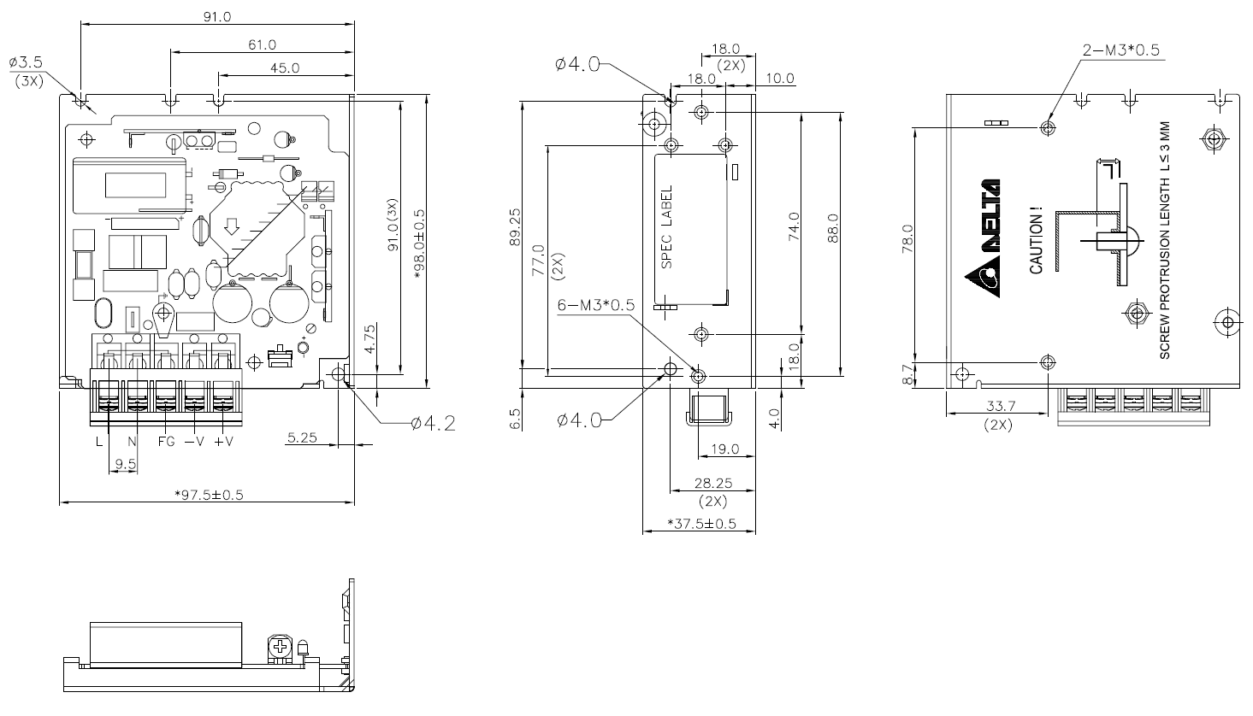

PML-12V35W1AH: Harness

**L x W x H:** 97.5 x 98 x 37.5 mm (3.84 x 3.86 x 1.48 inch)

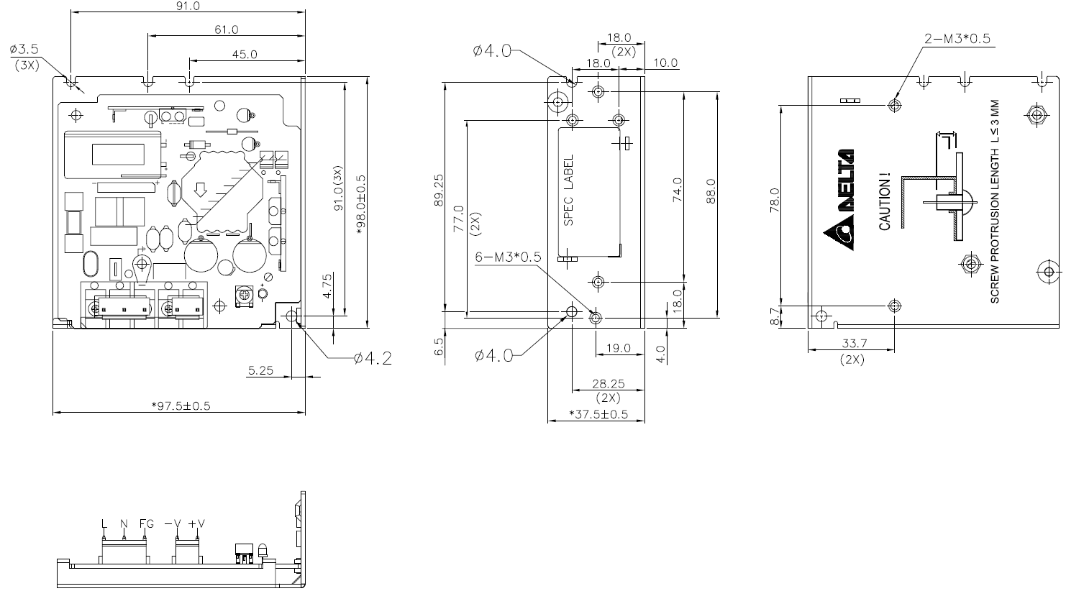

PMB-12V35W1AA: Terminal Block

**L x W x H:** 91 x 94.3 x 30.6 mm (3.58 x 3.71 x 1.20 inch)

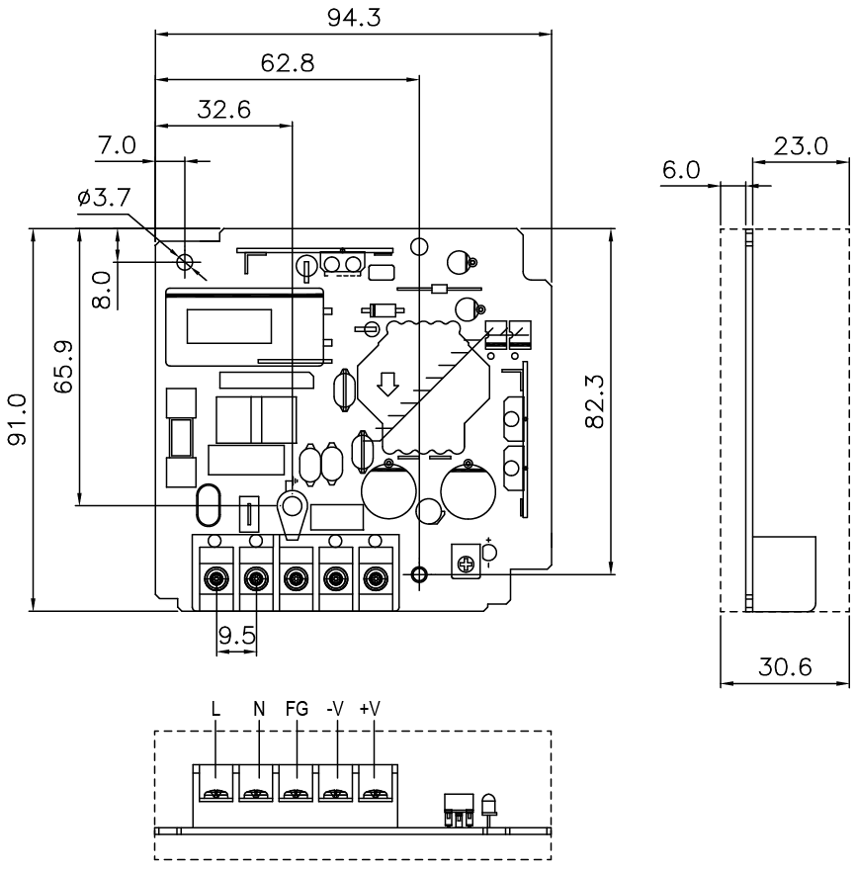

PMB-12V35W1AG: Front Face

**L x W x H:** 91 x 94.3 x 30.6 mm (3.58 x 3.71 x 1.20 inch)

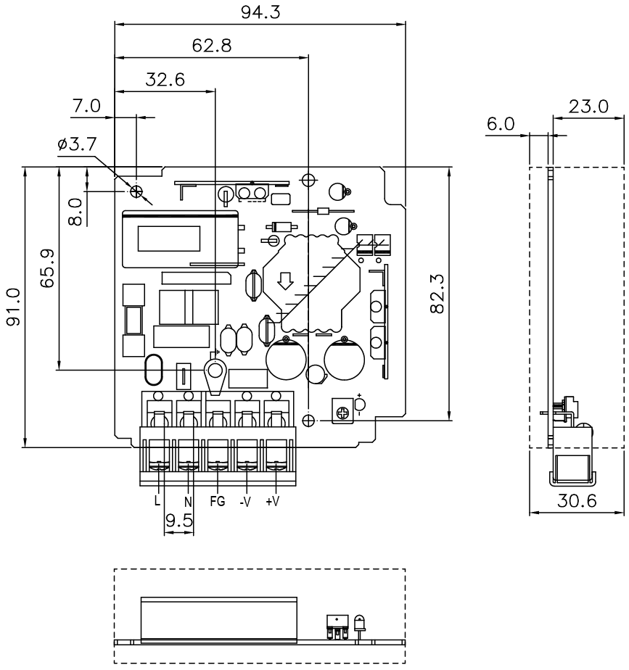

PMB-12V35W1AH: Harness

**L x W x H:** 91 x 94.3 x 30.6 mm (3.58 x 3.71 x 1.20 inch)

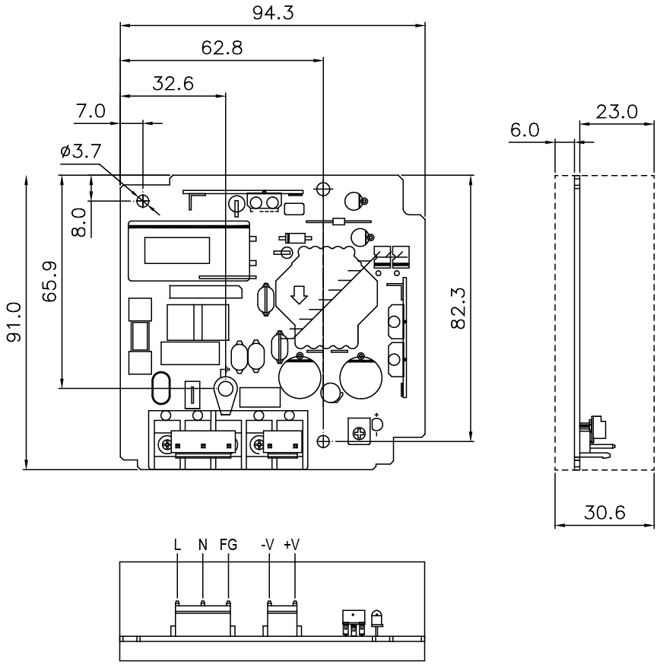

# Engineering Data

## Output Load De-rating VS Surrounding Air Temperature

**Note**

1. Power supply components may degrade, or be damaged, when the power supply is continuously used outside the shaded region, refer to the graph shown in Fig. 1.
2. If the output capacity is not reduced when the surrounding air temperature exceeds its specification as defined on Page 3 under “Environment”, the device will run into Over Temperature Protection. When activated, the output voltage will go into bouncing mode and will recover when the surrounding air temperature is lowered or the load is reduced as far as necessary to keep the device in working condition.
3. In order for the device to function in the manner intended, it is also necessary to keep a safety distance of 20 mm (0.79 inch) with adjacent units while the device is in operation.
4. Depending on the surrounding air temperature and output load delivered by the power supply, the device can be very hot!
5. If the device has to be mounted in any other orientation, please leave a message via the [Contact Us](https://www.deltapsu.com/en/contact/support) form.

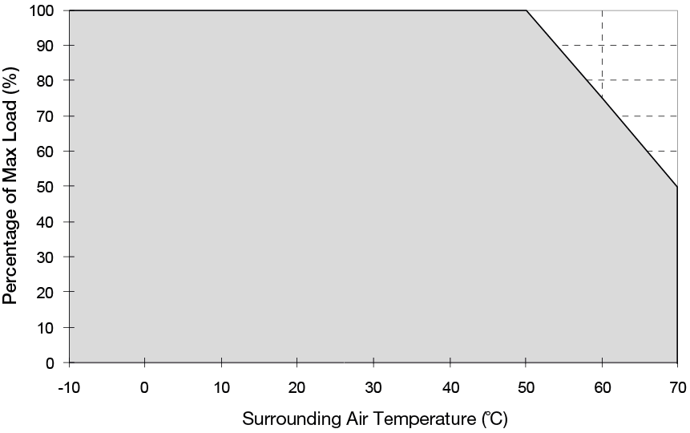

**Fig. 1 De-rating for Vertical and Horizontal Mounting Orientation**

> 50°C de-rate power by 2.5% / °C

## Output Load De-rating VS Input Voltage

* No output power de-rating for the input voltage from 90 Vac to 264 Vac

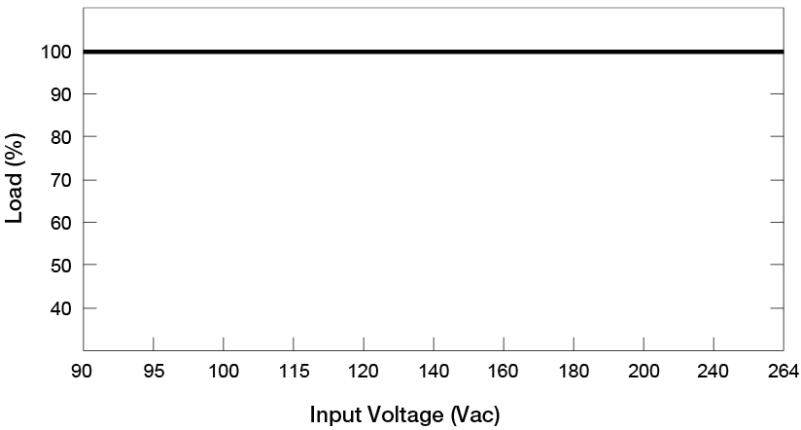

# Assembly & Installation

Ⓐ Mounting holes for power supply (device). The power supply shall be mounted on minimum 2 mounting holes using M3 screw minimum 5 mm (0.20 inch) length.

Ⓑ This surface belongs to customer’s end system or panel where the power supply is mounted.

Ⓒ Connector

|  |  |  |
| --- | --- | --- |
| **Side Mounting (Vertical)** | **Base Mounting (Vertical)** | **Side Mounting (Horizontal)** |
|  |  |  |
| **Fig. 2 Recommended Mounting Orientations** | | |

|  |
| --- |
| **Safety Distance**  D1 = 4.0 mm (0.16 inch) Min.  D2 = 6.0 mm (0.24 inch) Min. (For PMB Series) |
| **Fig. 3 Assembly Reference** |

Ensure the mounted device is kept at ≥ 4 mm (0.16 inch) safety distance at all sides from other components and equipments. In addition, to ensure sufficient convection cooling, always maintain a distance of ≥ 20 mm (0.79 inch) from ventilated surfaces while the device is in operation.

* **PM☐-12V35W1AA☐ / PM☐-12V35W1AG:** Use flexible cable (stranded or solid) of AWG No. 22-12. User should calculate and select the suitable wire specification (type/quantity/diameter) according to actual output current. The torque at the Connector shall not exceed 13 Kgf.cm (11.23 lbf.in). The insulation stripping length should not exceed 0.275” or 7 mm (Refer to Fig. 3).
* **PM☐-12V35W1AH:** Please refer the table below for the recommended mating connector, terminal and AWG wire size.

|  |  |  |  |  |
| --- | --- | --- | --- | --- |
|  | **Header (Board Mounting)** | **Mating Connector** | **Terminal** | **AWG** |
| **Input (JST)** | B3P5-VH(LF)(SN) | VHR-5N | SVH-21T-P1.1 | 22-18 |
| **Output (JST)** | B2P3-VH(LF)(SN) | VHR-3N |

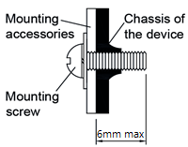

* **For PMT and PML Series (Refer to Fig. 4):** Only use M3 screw ≤ 6mm (0.23 inch) through the base mounting holes. This is to keep a safe distance between the screw and internal components. Recommended mounting tightening torque: 4~7 Kgf.cm (3.47~6.08 lbf.in).
* **For PMB Series: (Refer to Fig. 3):** The mounting holes on any mounting accessories for the device should be kept at a diameter of < 6.5 mm (0.26 inch). This is to ensure sufficient safety distance between the mounting screw and the components around the mounting holes on the PCBA. Therefore, the diameter of the mounting screw should be kept at < 6.5 mm (0.26 inch).

**Fig. 4 Mounting Screw**

## Safety Instructions

* If user’s mounting orientation is not according to the recommended mounting orientations, please consult Delta for further information.
* L frame (PML) and Open frame (PMB) options are to be manufactured by Delta and not to be reconfigured by users from the standard enclosed configuration.
* The device is not recommended to be placed on low thermal conductive surface. For example, plastics.
* The enclosure of the device can become very hot depending on the ambient temperature and load of the power supply. Do not touch the device while it is in operation or immediately after power is turned OFF. Risk of burning!
* Do not touch the terminals while power is being supplied. Risk of electric shock.
* Prevent any foreign metal, particles or conductors from entering the device through the openings during installation.  
  It may cause electric shock, safety hazard, fire and/or product failure.
* The power supply must be mounted by metal screws onto a grounded metal surface. It is highly recommended that the Earth terminal on the connector be connected to the grounded surface.
* Warning (For Standard Terminal Block and Front Face Terminal Block products): When connecting the device, secure Earth connection before connecting L and N. When disconnecting the device, remove L and N connections before removing the Earth connection.

# Functions

## Start-up Time

The time required for the output voltage to reach 90% of its final steady state set value, after the input voltage is applied.

## Rise Time

The time required for the output voltage to change from 10% to 90% of its final steady state set value.

## Hold-up Time

Time between the collapse of the AC input voltage, and the output falling to 95% of its steady state set value.

■ **Graph illustrating the Start-up Time, Rise Time, and Hold-up Time**

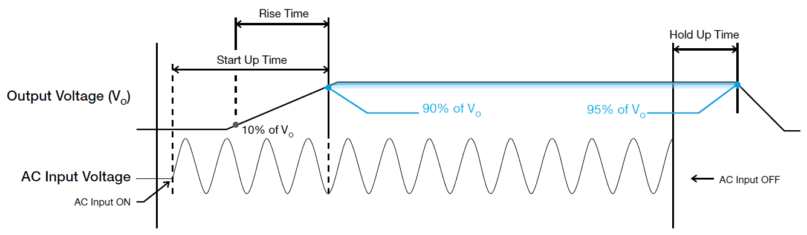

## Inrush Current

Inrush current is the peak, instantaneous, input current measured and, occurs when the input voltage is first applied. For AC input voltages, the maximum peak value of inrush current will occur during the first half cycle of the applied AC voltage. This peak value decreases exponentially during subsequent cycles of AC voltage.

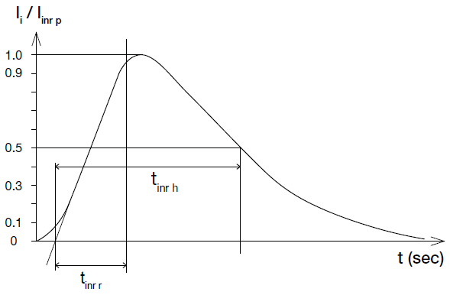

## Dynamic Response

The power supply output voltage will remains within ± 5% of its steady state value, when subjected to a dynamic load from 0 to 100% of its rated current.

* **50% duty cycle / 5 Hz to 1 KHz**

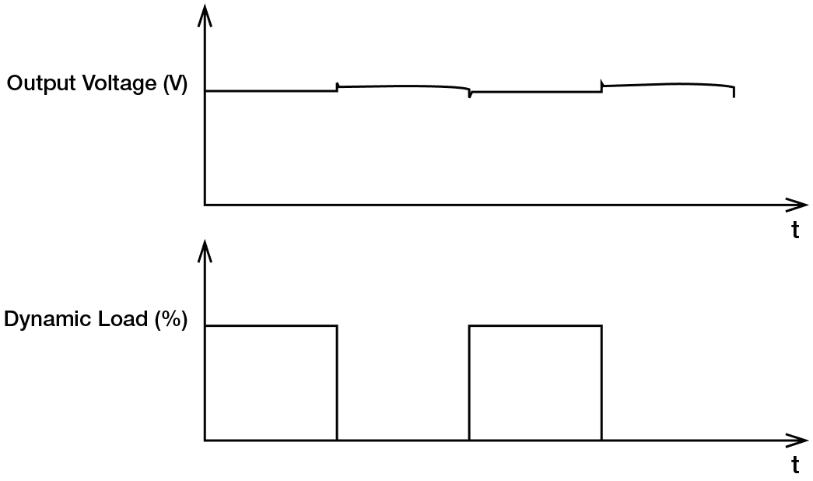

## Overload & Overcurrent Protections (Auto-Recovery)

The power supply’s Overload (OLP) and Overcurrent (OCP) Protections will be activated when output current exceeds 120% of IO (Max load). In such occurrence, the VO will start to droop and once the power supply has reached its maximum power limit, the protection is activated and the power supply will go into “Hiccup mode” (Auto-Recovery). The power supply will recover once the fault condition of the OLP and OCP is removed and IO is back within the specifications.

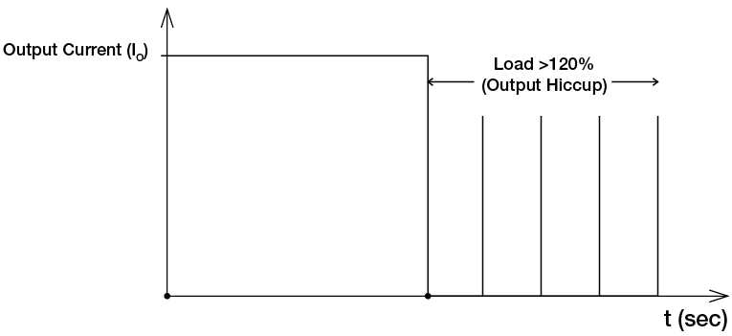

It is not recommended to prolong the duration of IO when it is <120% but >100%, since it may cause damage to the PSU.

## Short Circuit Protection (Auto-Recovery)

The power supply’s output OLP/OCP function also provides protection against short circuits. When a short circuit is applied, the output current will operate in “Hiccup mode”, as shown in the illustration in the OLP/OCP section on this page. The power supply will return to normal operation after the short circuit is removed.

## Overvoltage Protection (Auto-Recovery)

The power supply’s overvoltage circuit will be activated when its internal feedback circuit fails. The output voltage shall not exceed its specifications defined on Page 3 under “Protections”.

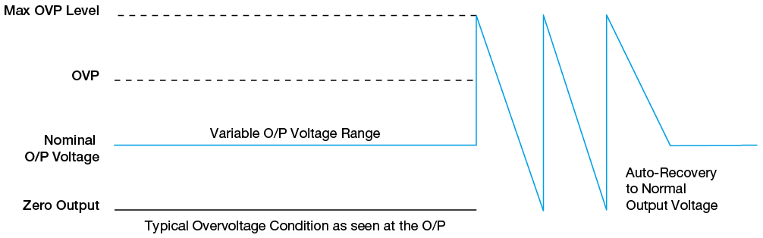

## Over Temperature Protection (Auto-Recovery)

As described in load de-rating section, the power supply also has Over Temperature Protection (OTP). In the event of a higher operating temperature at 100% load, the power supply will run into OTP when the operating temperature is beyond what is recommended in the de-rating graph. When activated, the output voltage will go into bouncing mode until the temperature drops to its normal operating temperature as recommended in the de-rating graph

# Others

## Attention

Delta provides all information in the datasheets on an “AS IS” basis and does not offer any kind of warranty through the information for using the product. In the event of any discrepancy between the information in the catalog and datasheets, the datasheets shall prevail (please refer to www.DeltaPSU.com for the latest datasheets information). Delta shall have no liability of indemnification for any claim or action arising from any error for the provided information in the datasheets. Customer shall take its responsibility for evaluation of using the product before placing an order with Delta.

Delta reserves the right to make changes to the information described in the datasheets without notice.

# Manufacturer and Authorized Representatives Information

## Manufacturer

Thailand

Delta Electronics (Thailand) PCL.

909 Pattana 1 Rd., Muang, Samutprakarn, 10280 Thailand

Taiwan

Delta Electronics, Inc.

3 Tungyuan Road, Chungli Industrial Zone, Taoyuan County  
32063, Taiwan

## Authorized Representatives

The Netherlands

Delta Greentech (Netherlands) B.V.

Zandsteen 15, 2132 MZ Hoofddorp, The Netherlands

United Kingdom

Delta Electronics Europe Limited

1 Redwood Court, Peel Park Campus,

East Kilbride, Glasgow, G74 5PF, United Kingdom

**Document Revision Record**

|  |  |  |  |  |
| --- | --- | --- | --- | --- |
| **Date** | **Item** | **Content Revised** | **Page Affected** | **Rev** |
| 12 Dec 16 | 1 | * Revised model numbering content * Updated TUV mark | 1 | 03 |
|  | 2 | Updated standards;   * Added “Safety Entry Low Voltage”.   CE: ”In conformance with EMC Directive **2014/30/EU** and Low Voltage Directive **2014/35/EU**” | 4 |
| 3 | Change drawing | 6-10 |
| 4 | Updated to align with new DS format   * Updated footer * Updated bullets * Output Voltage, Output Current: added “Rated” * Output Ratings/Characteristics: added “*” and remark under the table for power de-rating information. * Re-worded “Output Voltage Tolerance “ to “Factory Set Point Tolerance” * PARD: added “**” and remark under the table for measurement conditions. * Hold Up Time: added “(100% load)” at 115Vac. * Combine case chassis and cover * Added inch, lb, ft., lbf.in * Revised “EMC / Emissions” to “Emissions (CE & RE)”. * Engineering Data   + Re-worded “De-rating” to “Output Load De-rating VS Surrounding Air Temperature”   + Re-worded “Output De-rating VS Input Voltage” to “Output Load De‑rating VS Input Voltage”   + Revise “Note” item 5. * Functions: revised Start-up Time, Rise Time, Hold-up Time * Protections   + Added “(Auto-Recovery)”   + Updated description for “Over Temperature Protection” | All  1  1  2  2  2  2  3  1, 3, 6-13  4  11  14  15 |
| 10 Jan 18 | 1 | * Update Highlights & Features:   + Universal AC input voltage range * Modify Model number from PMT-12V35W1A☐ to PMT-12V35W1☐☐ * Modify CC code Blank – Without connector cover   A – With connector cover  B – With conformal coating   * Output Current: Add (xxxW max.) * Add Max Power Dissipation * Dynamic Response description : Add (Slew Rate: 0.1A/μS, 50% duty cycle @ 5Hz) * Revised Input Voltage Range : 90-264Vac * Add “Noise (1 meter from power supply) * Environment : Add “Over Voltage Category” * Protections : Add “Internal Fuse at L pin” & “Degree of Protection” * Emission (CE & RE): Replace CISPR22, EN55022 by CISPR32, EN55032 * Voltage Dips: Add “and Interruptions” * Engineering Data, revise “Note” item 2. * Assembly & Installation: for PM☐-12V35W1AHconnector   + Re-word “Use flexible cable (stranded or solid) of AWG No. 22-18. Please refer to Table 1 for the recommended Housing and Terminal.” to “Please refer the table below for the recommended mating connector, terminal and AWG wire size.”   + Re-word “Connector (Board Mounting)” to “Header (Board Mounting)”   + Re-word “Housing” to “Mating Connector”   + Add column for AWG wire size * Revised Mounting screw length : 6mm | 1  1  2  2  2  2  3  3  3  4  11  12  3, 12  12  13 | 04 |
| 11 Nov 18 | 1 | Change dynamic response Add attention paragraph | 14  15 |  |
| 8 May 20 | 1 2 3 | Change drawing Remove RoHS  Add connector type image | 6~8 4,15 1 | 06 |
| 06 Oct 20 | 1 | Add 62368-1 | 4 | 07 |
| 30 Apr 21 | 1 | - Add UKCA logo  - Change Certificates for Other Countries in Safety Standards section   * Add Manufacturer and Authorized Representatives Information * Remove Accessories part   BY Warat | 1 4 15 11 | 08 |
| 28 May 21 | 1 | Add EN/BS after EN 60950-1, EN 62368-1 in safety part Add EN/BS after EN 55032, EN 55024 in EMC part | 4 | 09 |
| 23 Sep 21 | 1 | Add BIS cert logo and detail | 1,4 | 10 |
| 24 Feb 22 | 1 | - Remove CCC mark  By Peeraya | 1, 4 | 08 |
| 05 July 24 | 1 | Add BIS CCC (only for PMF-12V35W1AA)  Revise Engineering data “5. contact form” By Warat | 1,4 8 | 09 |